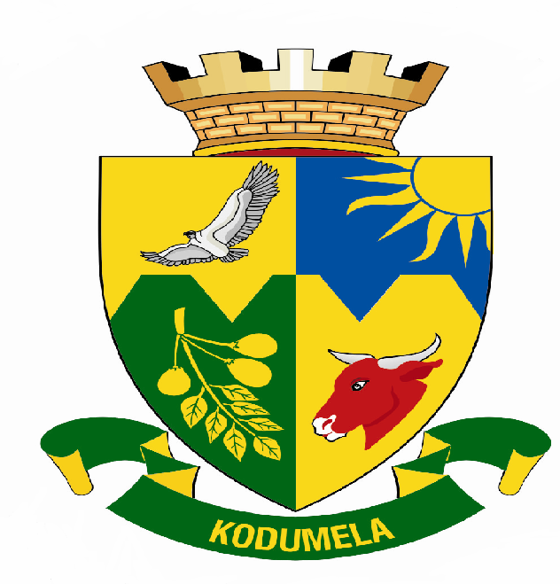
Blouberg Municipality
P.0 Box 1593
SENWABARWANA
0790
Tel: 015 505 7100
Fax: 015 505 0568/0296
E-mail:info@blouberg.limpopo.gov.za

MEDIA RELEASE

Taking today’s young people and nurture them into visionary leaders of tomorrow that will take the Municipality to better level, The Blouberg Municipality will host the Local Youth summit at the same time launch the 2007/08 Blouberg Youth Council.

The summit hosted under the theme ‘deepening youth participation through service’ is hosted in commemoration of the youth month ensuring that the legacy left by young lions of yesterday pave a better future for the young lions of today.

Blouberg Municipality is inviting your institution to come and witness the young generation of our area working towards a better service learning from the veterans. 300 delegates from various youth structures, community, religious and non-governmental organizations will be participating. The event is scheduled to take place as follows:

Date : 30 June 2007
Venue : Helen Franz School
Time : 10h00

Your presence at the event will be highly appreciated.

Issued by Communications on 25 June 2007.

For enquiries contact:
Manager Communications: Ms Phuti Matlou
Cell: 083 395 8417
Cell: 083 663 7703
Tel: 015 505 7100

